 | 7.1.29 Editors - 3D Viewport - Header - Grease Pencil - Edit mode - Point menu
Table of content
Edit Mode - Point Menu 2
Extrude 2
Last Operator Extrude Stroke Points 2
Move 2
Orientation 2
Mirror Editing 2
Proportional editing 2
Proportional Falloff 2
Proportional Size 2
Connected 2
Projected(2D) 2
Smooth 3
Last Operator Smooth Stroke 3
Repeat 3
Factor 3
Selected points 3
Position 3
Thickness 3
Strength 3
UV's 3
Vertex Groups 3
Add New Group 3
Set Corner Type submenu 4

Edit Mode - Point Menu

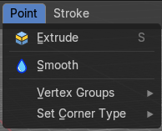

Extrude
Extrude selected points and move them. The new points stay connected with the original points of the stroke.
Extrude does not show in Select mode Stroke.

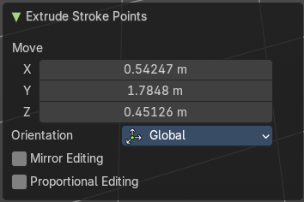
Last Operator Extrude Stroke Points

Move
The vector coordinates. They start relative to the initial vector.

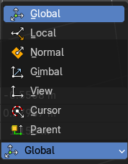
Orientation
The orientation in which the extrude happens.

Mirror Editing

Proportional editing
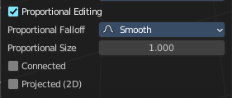
Enables proportional editing. Activating proportional editing reveals further settings.

Proportional Falloff
Adjust the falloff methods.

Proportional Size
See and adjust the falloff radius.

Connected
The proportional falloff gets calculated for connected parts only.

Projected(2D)
The proportional falloff gets calculated in the screen space. Depth doesn't play a role. When it's in the radius, then it gets calculated.

Smooth
Smoothens out the selected geometry.

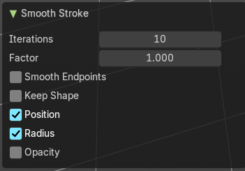
Last Operator Smooth Stroke

Repeat
How often to repeat the procedure.

Factor
The amount of the smoothness to apply.

Selected points
When enabled, limits the effect to only the selected points within the stroke.

Position
When enabled, the operator affect the points location.

Thickness
When enabled, the operator affect the points thickness.

Strength
When enabled, the operator affect the points strength (alpha).

UV's
When enabled, the operator affect the UV rotation on the points.


Vertex Groups
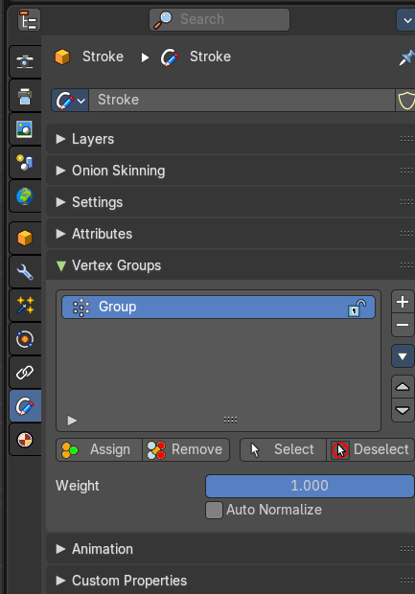
This menu contains just the Add New Group button.

Add New Group
Adds a new group.

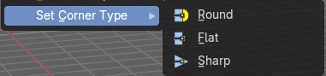
Set Corner Type submenu
Sets the corner type of the selected corners to the methods round, flat or sharp.

